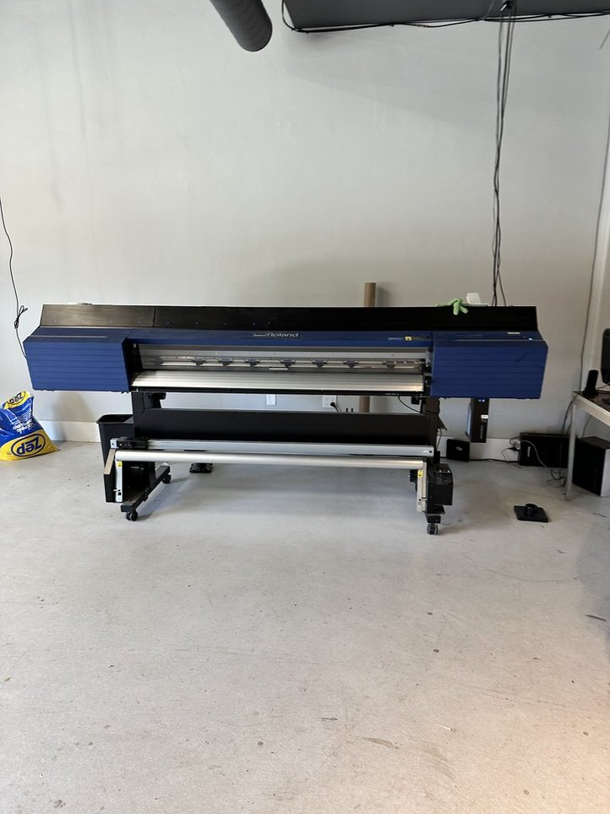
For Sale
Roland 64" VG2-640 printer
Roland 64" wide printer in excellent condition. Auto feed with a take up roller.
$9,000 Make me an offer, all offers considered!
Contact:
John E. Bollwinkel
John@acesignsutah.com
435-640-5418

